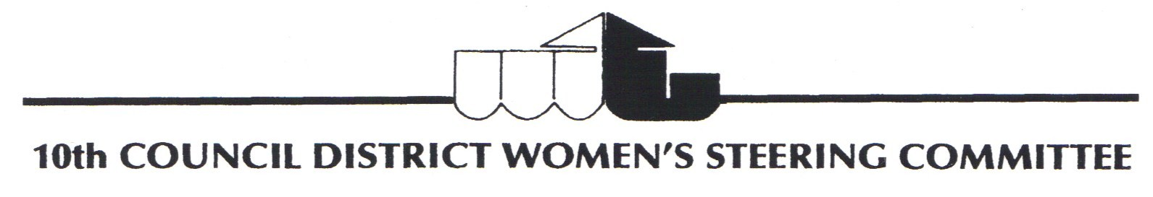
A Registered Trademark. All rights reserved.
P.O. Box 78372 Los Angeles, CA 90016 email: tenthcouncildistrictwsc@gmail.com 323-271-1071

MEMBERSHIP APPLICATION
Mission Statement: We are a non-partisan organization that works to improve the quality of life in the
10th Council District by promoting and supporting the civic participation and leadership of women who live, work, worship or attend school in the 10th Council District. 10th Council District is a 501 © (3) organization.

Name______________________________________________________________________________________
Street Address_______________________________________________________________________________
City, State & Zip Code_________________________________________________________________________
Home #._________________________________Cell #_____________________Work #____________________
E-Mail Address________________________ ___D.O.B (Mo/Date)______________Occupation_______________
Availability: Hours that you are available for volunteer assignments?
________Weekend AM ________ Weekend PM
_________Weekend Afternoons ________Weekday Evenings
Areas of Interests: Areas you are interest in participating?...Please Circle
Career Development______Fundraising____Committees____Newsletter Production____Special Projects_______________
Community & PoliceRelations____Education_____Hospitality______Education_________Legislation__________________
Membership_____Publicity_______Recreation/Cultural Enrichment________Sunshine_____________________________
How did you learn about us?....Please Circle
A Friend_________Community Organization_____________Newspaper______Website_____Other__________
Please summarize your previous voluntary experience. _______________________________________
____________________________________________________________________________________________Annual Membership is $50.00 a year or $200.00 for a lifetime membership
Meetings are held the 4th Saturday of every month. 11:00am. – 1:00pm
At the Nate Holden Performing Arts Center, 4718 Washington Blvd. Los Angeles, CA 90016
Telephone Number 323-371-1071
www.10thcdwsc.org. E-mail: jackienunn@sbcblobal.net Facebook: 10th Council District Women’s Steering Committee
Mail application to 10thCDWSC, P.O. Box 78372, Los Angeles, CA 90016

ENCLOSED IS MY CHECK IN THE AMOUNT OF $50.00 or $200.00 Lifetime
(Signature)_________________________________________________Dated____________

